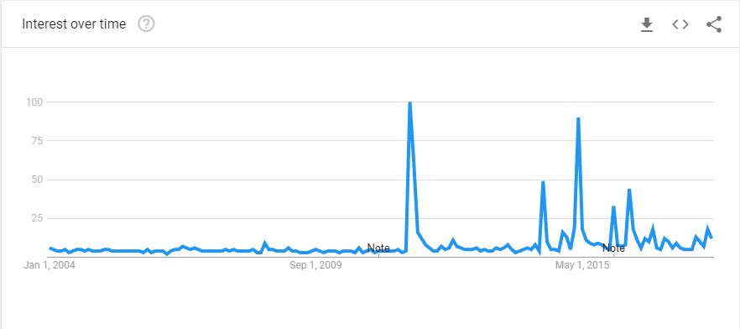

[1] Google Trends: ‘Listeria’

Sept 2011:

Jensen Farm: Cantaloupes [2]

July 2014:

[3] Wawona Packing Co: Nectarines, Peaches, and Plumbs

April 2015:

[4,5] Blue Bell Creameries: Ice cream

Jan 2016:

[6] Ohio Dole Processing Facility: Salad

May 2016:

[7] CRF Frozen Foods of Pasco: Frozen Vegetables

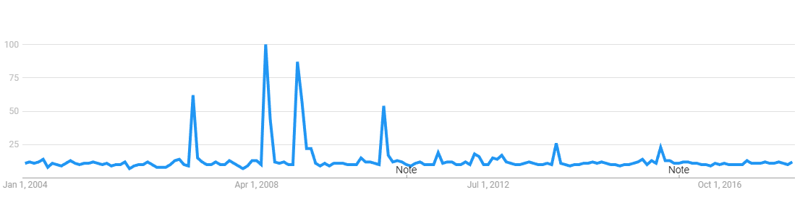

[8] Google Trends: ‘Salmonella’

Feb 2007:

[9] Peter Pan or Great Value: Peanut butter

June 2008:

[10] Jalapeno peppers

Aug 2010:

[12] Frozen Maymey Fruit Pulp

Jan 2009:

[11] Peanut Butter

[1] Google Trends, Accessed Feb 2018. [Online]. Available:

<https://trends.google.com/trends/explore?date=all&geo=US&q=%2Fm%2F0bkwm>

[2] Centers for Disease Control & Prevention, ‘Multistate Outbreak of Listeriosis Linked to Whole Cantaloupes from Jensen Farms, Colorado (FINAL UPDATE)’, Aug 2012, Accessed Feb 2018. [Online] Available:

<https://www.cdc.gov/listeria/outbreaks/cantaloupes-jensen-farms/index.html>

[3] CNN, ‘More stores affected by listeria fruit recall’, July 2014, Accessed Feb 2018. [Online] Available:

<https://edition.cnn.com/2014/07/22/health/costco-fruit-recall/index.html>

[4] Fortune. ‘How ice cream maker Blue Bell blew it’, Sept 2015, Accessed Feb 2018. [Online] Available:

<http://fortune.com/2015/09/25/blue-bell-listeria-recall/>

[5] Centers for Disease and Control Prevention, ‘Multistate Outbreak of Listeriosis Linked to Blue Bell Creameries Products (Final Update)’, July 2015, Accessed Feb 2018. [Online] Available:

<https://www.cdc.gov/listeria/outbreaks/ice-cream-03-15/index.html>

[6] Centers for Disease and Control Prevention, ‘Multistate Outbreak of Listeriosis Linked to Packaged Salads Produced at Springfield, Ohio Dole Processing Facility (Final Update)’, March 2016, Accessed Feb 2018. [Online] Available:

<https://www.cdc.gov/listeria/outbreaks/bagged-salads-01-16/index.html>

[7] Centers for Disease and Control Prevention, ‘Multistate Outbreak of Listeriosis Linked to Frozen Vegetables (Final Update)’, July 2016, Accessed Feb 2018. [Online] Available:

<https://www.cdc.gov/listeria/outbreaks/frozen-vegetables-05-16/index.html>

[8] Google Trends, Accessed Feb 2018. [Online]. Available:

<https://trends.google.com/trends/explore?date=all&geo=US&q=%2Fm%2F0bkwm>

[9] US National Library of Medicine, ‘A national outbreak of Salmonella serotype Tennessee infections from contaminated peanut butter: a new food vehicle for salmonellosis in the United States.’, June 2007, Accessed: Feb 2018. [Online] Available:

<https://www.ncbi.nlm.nih.gov/pubmed/21810748>

[10] Centers for Disease Control and Prevention, Multistate Outbreak of Salmonella Saintpaul Infections Linked to Raw Produce (FINAL UPDATE)’, Aug 2008, Accessed: Feb 2018. [Online] Available:

<https://www.cdc.gov/salmonella/2008/raw-produce-8-28-2008.html>

[11] Centers for Disease Control and Prevention, Multistate Outbreak of Salmonella Saintpaul Infections Linked to Raw Produce (FINAL UPDATE)’, May 2009, Accessed: Feb 2018. [Online] Available:

<https://www.cdc.gov/salmonella/2009/peanut-butter-2008-2009.html>

[12] Centers for Disease Control and Prevention, ‘Multistate Outbreak of Human Typhoid Fever Infections Associated with Frozen Mamey Fruit Pulp (Final Update)’, Aug 2010,

https://www.cdc.gov/salmonella/2010/frozen-fruit-pulp-8-25-10.html